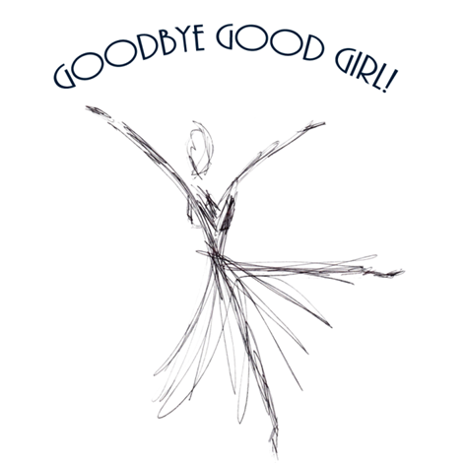

Qualifying Questionnaire for the

Entrepreneurial Rule-Breakers Group
for women who are done with waiting to

make a difference!

I created this questionnaire to determine that the women who join these groups are committed to three crucial things: (1) Their own growth, (2) The challenge of walking through resistance, (3) The responsibility of showing up for the group.

It takes a great deal of determination, passion and vision to live that commitment. Goodbye Good Girl’s focus is to live our vision to our fullest ability, now, instead of remaining in a “work toward it” mode. In these groups, we learn to identify with our authentic, strong, self-confident selves, in the ways that are unique to each individual woman, and we practice those strengths now.

There is no time to waste; if you feel that you have been continually waiting, and want to walk your path now, instead of continuing to prepare for it, please answer the questions below honestly. And please allow me to thank you in advance for your openness, and for your interest. It’s an honor to be on the journey with you!

- How long have you “worked on yourself” to become the empowered woman you are, and want to be even more of?

- What have you not felt able to overcome in this journey toward empowerment?

- Are you ready to commit to attending all 7 weeks of 90-minute sessions? Life happens – unforeseen disasters happen. But “not feeling like it” is far from a disaster. If you come to this group, you are expected to be there every week. Will you make that commitment to yourself and the others?

- Would you like to find a Community of entrepreneurial women that is truly about connection and mutual assistance? And would you be open to learning new ways to make the most of that opportunity?

- Why do you feel drawn to this group? And what are you determined to do with your business? In other words, what is your most passionate and authentic vision for your business?

- How do you feel you would you benefit from a Community of like-minded entrepreneurial women?

- Who do you want to be, at your strongest? Please describe your strongest, best self, whether you feel you are “there” now, or not.

Thank you very much for filling out this questionnaire!

I will be contacting you very shortly. In the meantime, you might want to go to the Home page of www.GoodbyeGoodGirl.com and download “The Five Strengths of Feminine Power”.

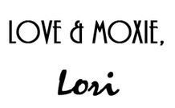
Wishing you all kinds of…

